|  |
| --- |
|  |
| 新概念 3 册 |
| Lesson18 Electric currents in modern art |

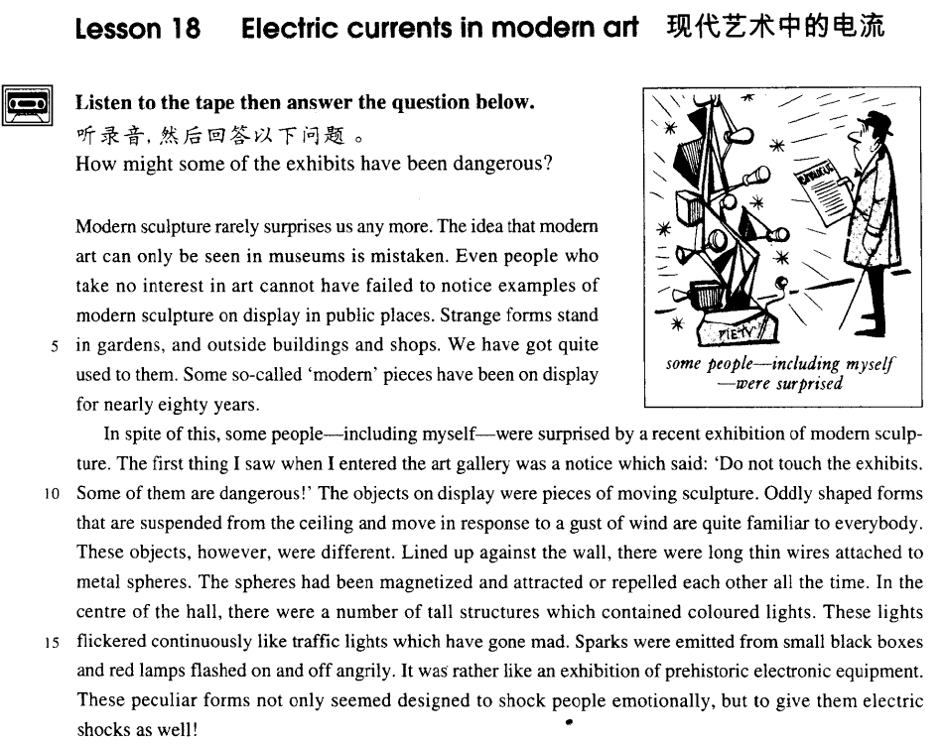

课文

Modern sculpture rarely surprises us any more.

现代雕塑不再使我们感到惊讶了。

The idea that modern art can only be seen in museums is mistaken.

那种认为现代艺术只能在博物馆里才能看到的观点是错误的。

Even people who take no interest in art cannot have failed to notice examples of modern sculpture on display in public places.

即使是对艺术不感兴趣的人也不会注意到在公共场所展示的现代艺术品。

Strange forms stand in gardens, and outside buildings and shops.

公园里、大楼和商店外竖立着的奇形怪状的雕塑，

We have got quite used to them.

对这些，我们已经司空见惯了。

Some so-called 'modern' pieces have been on display for nearly 80 years.

有些所谓的“现代”艺术品在那里已经陈列了近80年了。

In spite of this, some people -- including myself -- were surprised by a recent exhibition of modern sculpture.

尽管如此，最近举办的一次现代雕塑展览还是使一些人（包括我在内）大吃了一惊。

The first thing I saw when I entered the art gallery was a notice which said: 'Do not touch the exhibits, some of them are dangerous!'

走进展厅首先看到的是一张告示，上面写着“切勿触摸展品，某些展品有危险！”

The objects on display were pieces of moving sculpture.

展品都是些活动的雕像。

Oddly shaped forms that are suspended from the ceiling and move in response to a gust of wind are quite familiar to everybody.

人们所熟悉的是悬挂在天花板上、造型奇特、随风飘荡的雕塑品。

These objects, however, were different. Lined up against the wall, there were long thin wires attached to metal spheres.

这些展品却使人大开眼界。靠墙排列着许多细长的电线，而电线又连着金属球。

The spheres had been magnetized and attracted or repelled each other all the time.

金属球经过磁化，互相之间不停地相互吸引或相互排斥。

In the centre of the hall, there were a number of tall structures which contained coloured lights.

展厅中央是装有彩色灯泡的许多高高的构件。

These lights flickered continuously like traffic lights which have gone mad.

灯泡一刻不停地闪烁着，就像失去了控制的红绿灯。

Sparks were emitted from small black boxes and red lamps flashed on and off angrily.

小黑盒子里迸出火花，红色灯泡发怒似地忽明忽暗。

It was rather like an exhibition of prehistoric electronic equipment.

这儿倒像是在展览古老的电子设备。

These peculiar forms not only seemed designed to shock people emotionally, but to give them electric shocks as well!

好像设计这些奇形怪状的展品不仅是为了给人感情上的强烈刺激，而且还想给人以电击似的！

词汇讲解

* **current** ['kʌrənt] n. 电流

**alternating current (AC)** 交流电

**direct current (DC)** 直流电

* Is the wire live? 这根电线有电吗
* The plug broke, exposing live wires.

**a two-pin plug** 两厢插头

**a three-pin plug socket** 三厢插头

**water current** 水流

**air current** 气流

* swim with the current 顺着水流游
* swim against the current 逆流
* the current president 现任总统
* current affairs 时事
* the current economic situation 当前的经济状况
* **mistaken** [mɪ'steɪkən] adj. 错误的
* mistaken ideas 错误的观念
* a mistaken judgment 错误判断

**be mistaken about …** 把…搞错

* I was mistaken about her age.

**相关形容词**

**wrong** ***adj.*** 错误的；失常的；不适当的

**false** ***adj.*** 错误的；虚伪的；伪造的

**erroneous** 【书】 ***adj.*** 错误的；不正确的

**fallacious** 【书】***adj.*** 谬误的；骗人的；靠不住的；不合理的

**相关名词**

**mistake** ***n.*** 错误；误会；过失

**error** ***n.*** 误差；错误；过失

* a technical error

**blunder** ***n.*** （强调由于粗心）大错

* It was a blunder to marry such a lazy-bones.

**fault** (强调责任) ***n.*** 故障；[地质] 断层；错误；缺点；毛病；（网球等）发球失误

* It’s your fault!

**fallacy** (强调错误观念，错误想法)***n.*** 谬论，谬误

* It is a common fallacy that women are worse drivers than men.

**相关动词表达**

**make a mistake**

**commit a fallacy** （强调逻辑的错误）

* The author commits a fallacy of false analogy.

err 【书】***vi.*** 犯错；做错；犯罪；走上歧途

* To err is human, to forgive divine. 凡人多舛误, 唯神能见宥.— Alexander Pope
* **oddly** ['ɒdli] adv. 奇怪地，古怪地

**odd *adj.*** 奇数的；古怪的；剩余的；临时的；零散的

* What an odd man he is!

**an odd number** 基数

**an even number** 偶数

**相关形容词**

**strange** ***adj.*** 奇怪的；陌生的；外行的

**unusual** ***adj.*** 不寻常的；与众不同的；不平常的

**peculiar** ***adj.*** 特殊的；独特的；奇怪的；罕见的

* a peculiar smell
* a most peculiar story

**be peculiar to …** 是…特有的

* Pandas are peculiar to China. 大熊猫是中国特有的

**weird** ***adj.*** 怪异的；不可思议的；超自然的 （听起来怪怪的）

* I heard some weird noises coming from outside.

**eccentric** ***adj.*** 古怪的，反常的 (形容人)

* Our neighbor is an eccentric old lady who has about 25 cats.

**bizarre** ***adj.*** 奇异的（指态度，容貌，款式等）

**outlandish** ***adj.*** 古怪的；奇异的；异国风格的；偏僻的

* She came to the party wearing a bizarre / an outlandish costume and a blond wig.
* **attach** [ə'tætʃ] v. 连上，系上，贴上，附加上

**attach … to …** 把…附加上…

* attach a photo to the form
* attach a rope to the branch
* They attached a number of conditions to the agreement.

**attach … to …** 认为

* China attaches great importance / significance to agriculture.
* She attaches great value to financial independence.
* **sphere** [sfɪə(r)] n. 球体；领域

**在…领域**

**in the scientific（可学） / political（政治） / cultural(文化) / educational（教育） … sphere / area / field / world / realm / domain**

**atmosphere *n.*** 气氛；大气；空气

**hemisphere *n.*** 半球

**the northern / southern / eastern / western hemisphere**

* **repel** [rɪ'pel] v. 排斥
* Oil repels water.

**attract** ***v.*** 吸引

* His behavior repels（讨厌） me.
* The food repels （讨厌）my stomach.

**be repelled by …** …令人讨厌

* I was repelled by his behavior.

**repellent** ***adj.*** 排斥的；防水的；弹回的；令人讨厌的

**repellent smell / behavior** 令人厌恶的行为/举止

**动词 形容词**

**repel** **repellent**

**repulse repulsive**

**revolt revolting**

**disgust disgusting**

* You would not be able to understand why some people find it **repulsive**.
* **课后习题讲解，Lesson21**

11 Humphries soon became ___A___ Mendoza’s success. (11.13-14)

(a) jealous of (b) disinterested in (c) revolted by (d) changed by

**词根“pel” = push**

**repel** **compel** / **impel**

be / feel compelled to do 必须做某事（强调外因）

be / feel impelled to do 必须做某事（强调内因）

expel ***vt.*** 驱逐；开除

propel ***vt.*** 推进；驱使；激励；驱策

* **flicker** ['flɪkə(r)]v. 闪烁
* The candle flickered in the wind.

**twinkle** （强调微弱闪烁）***vt.*** 使闪耀；闪耀 ***vi.*** 闪烁；发亮

* Twinkle, twinkle, little star, like a diamond in the sky. — Jane Taylor

**sparkle** (强调很多碎碎亮点发出强光，如钻石)***vt.*** 使闪耀；使发光 ***vi.*** 闪耀；发泡；活跃

**glitter** ***vi.*** 闪光；闪烁

* The diamond sparkled in the sunlight.
* All that glitters is not gold. — William Shakespeare

**flash** (强调一瞬强光) ***n.*** 闪光，闪现；一瞬间

* a flash of lightning

**a flash in the pan** 昙花一现

* His first novel proved to be a flash in the pan. He never wrote another.
* **emit** [ɪ'mɪt] v. 放射，发射
* Fireflies emit light but not heat.

**give off** 发射 (光线，气体，热量)

**discharge** 发出（抽象事物）

**launch *vt.*** 发射（导弹、火箭等）

* launch a rocket / missile / satellite

**词根词缀：**

**emit: “e ”(out) + “mit ”(send)**

**submit:** “**sub ”(under) + “mit ”**

**transmit**: “**trans ” (across)+ “mit ”**

* sexually transmitted diseases
* The US open will be transmitted live via satellite.

**vomit**: **“vo ”(eat) + “mit ”**

**omit**: “**o ”=“ob ”(away) + “mit ”**

课文讲解

# Modern sculpture rarely surprises us any more.

**频率词：几乎、很少**

**rarely**

**seldom**

**almost never**

**hardly ever**

* Though he owned a large car, he hardly ever used it, preferring always to go on foot.

**课文写法替换**：语法“部分倒装”

Rarely / Seldom does modern sculpture surprise us any more. （强调句首状语）

**“使”意动词：**

**astonish**

**disturb**

**remind**

**confuse**

**convince**

* His reaction made me feel deeply disappointed. **不地道**
* His reaction deeply disappointed me. **地道表达**
* What he said made me totally confused. **不地道**
* What he said totally confused me. **地道表达**

# The idea that modern art can only be seen in museums is mistaken.

* When reports came into London Zoo that a wild puma had been spotted forty-five miles south of London, they were not taken seriously.

**书面语表达：圆周句（掉尾句）**

* The idea is mistaken that modern art can only be seen in museums.
* The idea that modern art can only be seen in museums is **mistaken**. （强调句尾**mistaken）**
* That all great art has this power of suggesting a world beyond is **undeniable**. （强调句尾**undeniable）**
* It is undeniable **that all great art has this power of suggesting a world beyond.**
* Although Tchaikovsky himself thought of the Pathetic Symphony as his crowning masterpiece, the premiere on October 28th 1893 in St. Petersburg proved a **disappointment**. （强调句尾**disappointment）**

# Even people who take no interest in art cannot have failed to notice examples *of modern sculpture on display in public places*.

知识点（一）

表达“对…感兴趣”

**be interested in …**

**take … interest in …**

**take an interest in …** 只用单数

**take no interest in …**

**take little interest in …**

**take a lot of interest in …** （非正式）

**take considerable interest in …** （正式）

* Kidnappers are rarely interested in animals, but they recently **took considerable interest in** Mrs. Eleanor Ramsay's cat.

**take pride in ...** 对…骄傲

* You should **take pride in** your work.

**take pleasure / delight in ...** 喜欢…

* College students seem to **take pleasure / delight in** practical jokes.

**take comfort in ...** 对…感到欣慰

* I know she goes out a lot at night, but I **take comfort in** the fact that she's always with friends.

**take pity on ...** 对…同情 （注意介词搭配）

* I **took pity on** the beggar and gave him some change.

知识点（二）

**cannot have failed to notice …** 双重否定

**must have noticed …**

* Cats never fail to fascinate human beings.

知识点（三）

**“on + 名词”表示处于某种状态**

**on display / show / exhibition**

* The house is **on** sale.
* The workers are **on** strike.
* I’m here **on** vacation.
* I’m here **on** business.
* The nurse is **on** call 24 hours a day.

# Strange forms stand in gardens, and outside buildings and shops.

Strange forms （of sculpture） stand in gardens, and outside buildings and shops.

# We have got quite used to them.

**be / get / become used to(介词) …** 习惯了…

* “We'll get used to that Bill,” said the vicar.

**be / get / become accustomed to(介词) …** 对…习惯了 （更正式）

* We have got quite accustomed to them.
* **听力真题：**

1. Read a gas meter.
2. Start a camp fire.
3. Get gas for his car.
4. Cook some food.

M: I’**m** not **accustomed to** using a gas stove.

W: It’s simple. Just turn the knob until the burner lights then adjust the flame.

Q: What is the man going to do?

Answer: (D) Cook some food.

**be / get / become familiar with …** 熟悉了…

* We have **got** quite **familiar with** them.

**be adapted to(介词) …** 适应了…

* I **am adapted to** Beijing’s dry climate.

# Some so-called 'modern' pieces have been on display for nearly 80 years.

**so-called** 所谓的（名不副实的）

* Where are your **so-called** friends now?

# In spite of this, some people -- including myself -- were surprised by a recent exhibition of modern sculpture.

**表达“我也一样”插入语**

—**including myself**—

—**as well as myself**—

—**no less than myself**—

# The first thing I saw *when I entered the art gallery* was a notice *which said: 'Do not touch the exhibits. Some of them are dangerous!'*

**say** v. 上面写着 …

* The sign **says** ‘Keep Out’.
* What did the letter **say**?
* My watch **says** four o’clock.
* A tiny asterisk conducted me to a footnote at the bottom of the page. It **said**: 'This service has been suspended.'

**go** v. 一句话一个故事是怎么说的；一首歌是怎么唱的

* As the old saying **goes**, ‘look before you leap’.
* The story **goes** that the prince was turned to a frog.
* How does the song **go**?

**Keep away from** the exhibits. 不要触碰

# The objects on display were pieces of moving sculpture.

# Oddly shaped forms that are suspended from the ceiling and move in response to a gust of wind are quite familiar to everybody.

知识点（一）

**shaped** a.有...形状的

* a strangely **shaped** carrot
* She has a perfectly **shaped** figure.
* heart-**shaped**
* pear-**shaped**
* V-**shaped**

知识点（二）

**be suspended from …** 悬挂

**hang from …**悬挂

* His driver’s license was **suspended**.(中止)

知识点（三）

**in response to …** 作为对…的反应

* The president stepped down in response to public pressure.

知识点（四）

**“量词”**

* a **gust** of wind 一**阵**风
* a flash of lightning 一道闪电
* a **peal** of thunder 一声雷
* a **fit** of coughing 一**阵**咳嗽
* a **round** of applause 一**阵**掌声
* **peals / gales** of laughter **阵阵**笑声

**be familiar with …** 对…很属性

**be familiar to …** 对…来说很熟悉

* Many readers **are familiar with** the name Harry Potter.
* The name Harry Potter **is familiar to** many readers.

# These objects, however, were different. Lined up against the wall, there were long thin wires attached to metal spheres.

Lined up against the wall, there were **long thin wires**（主语） *attached to metal spheres*.

**line sth. up** 把…排成一排

* The books **are lined up** on the shelf.

**line up** 排队

* Line up, everybody!

**cut in line** 加塞

**attach sth. to sth.** 把…连接到…

* **造句**：在桌上排列着一些崭新的 (brand-new) 电脑，而电脑上又连着 (connect) 打印机(printer)。
* Lined up on the table, there are a number of brand-new computers connected to printers.

# The spheres had been magnetized and attracted or repelled each other all the time.

**表达“一直……，不停地…… ”**

**all the time**

**on and on**

**continuously**

**constantly**

**without stopping**

# In the centre of the hall, there were a number of tall structures which contained coloured lights.

**colored lights** 有颜色的灯

**colorful lights** 五颜六色的灯

* … **colorful** rugs from Persia

# These lights flickered continuously like traffic lights *which have gone mad*.

**continuously** 强调一刻不停，一直持续下渠的

**continually** 频繁发生的 （含贬义，不希望发生的事总是发生）

* be **always** / **continually** doing
* He is **continually** being late.
* He is **continually** asking me for money.

知识点（一）

**go,系动词，往坏的方向变**

* **go** mad
* **go** crazy
* **go** wild
* **go** bananas
* **go** nuts
* Oceans apart, day after day, and I slowly **go** insane.

# Sparks were emitted from small black boxes and red lamps flashed on and off angrily.

**on and off** 断断续续地

**off and on**

反义：**on and on** 持续不停地

# It was rather like an exhibition of prehistoric electronic equipment.

**写作表达：夸张 hyperbole**

prehistoric 固定的夸张修辞

**中文夸张修辞：**

* 白发三千丈, 缘愁似个长
* 危楼高百尺, 手可摘星辰
* 燕山雪花大如席, 片片吹落轩辕台

**英文夸张修辞：**

* Everybody was clapping their hands off.
* I didn’t sleep a wink last night.
* He has a skeleton of a wife.

# These peculiar forms not only seemed designed to shock people emotionally, but to give them electric shocks as well!

shock

**写作表达：双关 pun**

**中文双关修辞：**

杨柳青青江水平，闻郎江上唱歌声。东边日出西边雨，道是无**晴**还有**晴。**刘禹锡《竹枝词》

**英文双关修辞：**

* Lesson19 A very **dear** cat
* More **sun** and **air** for your **son** and **heir**.
* We must all **hang together** or we shall all **hang separately**.
* -What do lawyers do when they die?
* -**Lie still.**
* The professor tapped on his desk and shouted, “Gentlemen, **order**!” The entire class yelled, “Beer!”.